September 2025

**Parking**

Dear families

Please be reminded that you should not park in the staff carpark before or after school unless in receipt of a permit that allows you to do so. Permits should be clearly displayed so that staff supervising the academy gate allow access.

The staff car park is used as pedestrian walk way before and after school and it is vital that this is kept clear so that families can leave the academy safely.

As a site serving hundreds of students, many who have complex medical needs, there are times where emergency services may require access to the site. This is not possible when dangerous and careless parking is taking place. If you have a permit, please ensure that you only park in designated parking bays.

Thank you in advance for your co-operation, understanding and support.

Yours sincerely

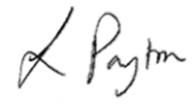

Laura Payton

Acting Head of School